Ecosystems - Wolves in Yellowstone
6th Grade Creative Dance Lesson Plan

Content Objective
Written by Jana Shumway
To compliment PAUL NANCE’S science lesson about Wolves in Yellowstone

6th Grade SCIENCE Strand 6.4: Stability and Change in Ecosystems: 6.4.4: Construct an argument supported by evidence that the stability of populations is affected by changes to an ecosystem. Emphasize how changes to living and nonliving components in an ecosystem affect populations in that ecosystem. Examples could include Utah ecosystems such as mountains, Great Salt Lake, wetlands, or deserts. DANCE: Strand: CREATE Standard 6.D.CR.2: Use a variety of stimuli and solve multiple movement problems.
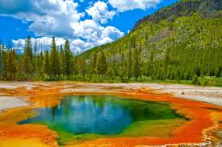
Length of Lesson: 45 + minutes

Music and Materials needed
Pictures of the following:
Wolves, Elk
Aspen, Willow, Cottonwood Trees Streams, Soil
Ravens and Bald Eagles Beavers and Dams Aquatic Life
Music: I use “Spirit of the Forest“ by Baka Beyond; “The Drift” by Blackmill; and “Water Drums“ by Baka Forest People of Southeast Cameroon (for streams & aquatic life if desired)
Explore with movement
Play “Spirit of the Forest” as you introduce movement for the following living and non-living parts of Yellowstone National Park's ecosystem.
WOLVES Do big lunges with power and strength. While lunging push away with hands and arms in different directions.
ELK Create bent shapes above the head with the arms. Walk quickly while maintaining the shape of the arms. Walk in curved, zig zag and straight pathways.
TREES
(Aspen, Willow, Cottonwood) Create the shape of a tree (bent, twisted, crooked shapes). Slowly let the shape swing and sway while keeping the feet glued to the floor (axial movement).

STREAMS Create one long line of kids. Have the leader run in curving pathways with sustained movement. Add arms and jumping turns.
SOIL - with mercury & acids Create an asymmetrical shape on the ground. Slowly let the shape morph into another asymmetrical, unique shape. Keep changing from one shape to the next keeping each shape low on the ground.
RAVENS / BALD EAGLES Soar up high. Create two circling pathways. Swoop down low, then run and leap.
BEAVERS / DAMS Have everyone create a shape that connects to another person to make a “dam”. Fit a
portion of each shape into the negative space of another shape and have each shape be on a different level.

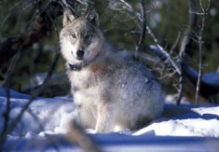
AQUATIC LIFE Do “swimming” movements. Push and pull with hands and arms in a variety of ways while traveling
2

.

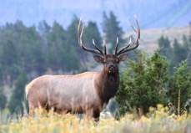

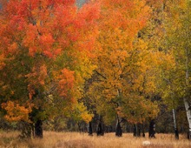

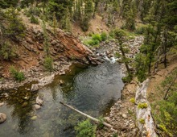

Relationships of the Living and Non-Living things
Repeat the above movements so all the students are clear with what movement represents which non-living or living thing that exists in Yellowstone National Park. Please note that there are even more living and non-living things that were affected when Yellowstone removed the wolves from the park. But from the examples used in this lesson the students
will get the point about how each part of an ecosystem is valuable and if something is removed, populations in the ecosystem will be affected.

Now explain the relationships that the non-living and living things have with each other and how one will affect the other. First, have the students stand in lines in front of the 8 pictures that are placed on the wall. Depending on the size of your class, each line should not have more than 3-4 students in it. (So there will be 3-4 wolves, 3-4 elk, etc.).

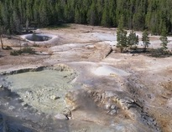

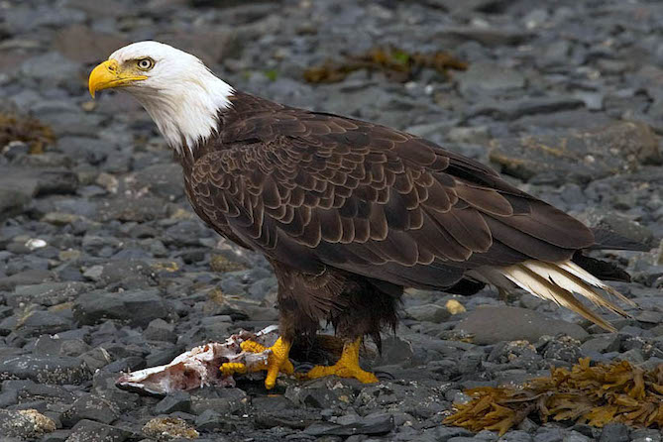
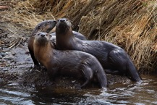
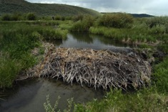

Play “The Drift” by Blackmill for this section.

First set the scene of Yellowstone Park in the 1920’s

- Have the TREES go out on the floor and create their bent, crooked, twisted, swaying shapes.

- Then have the STREAMS go in curving pathways really close to and around the swaying, swinging TREE shapes. Plants flourish best by rivers and streams.

- Then have the WOLVES enter lunging with power and move in and around the TREES and STREAMS.

- Then tell the RAVENS and BALD EAGLES that they get an EXTRA PART. They get to enter as HUMANS and they get to track down the wolves. The HUMANS can run in zig zag, darting pathways. When they touch a wolf, the wolf will collapse and “die”. Then the wolves need to roll off to the side of the room. This represents taking the wolves out of Yellowstone park.

- Without wolves, the elk are not hunted and they stay closer to the streams and rivers and eat the surrounding plants. Have the ELK twist around the TREE shapes while maintaining the bent shape with the top part of their body and while traveling from one TREE to the next.

- With too many elk eating the trees by the rivers the trees cannot regenerate so the trees die. The TREES will melt down, hovering and hanging low as the ELK twist and circle around them.

- Because the trees cannot regenerate, they do not help to stabilize the banks of the rivers, so STREAMS start to erode. Have the STREAMS spread out. No longer can they follow in a line with several students. Instead they can travel as individuals in curving pathways around the “dead” TREES that are hanging and hovering.

- As the streams erode, the soil loses its acids. Without the acids, the aquatic life dies. Have the SOIL start to move low to the ground while the AQUATIC LIFE is doing the “swimming” movements (pushing and pulling with arms) around the soil. Have the SOIL become lifeless and freeze in a shape on the ground.

- After the SOIL becomes lifeless, have the AQUATIC LIFE slowly swim lower and lower until they, too, are lifeless on the ground. Notice how lifeless Yellowstone is at this point.

- Now reintroduce the WOLVES (70 years later!) with powerful lunges. Then have the ELK travel out into the space. As the WOLVES get near the elk, have them pounce, leap and jump and the ELK will either collapse or travel fast and get to a new location.

- Now since the ELK can no longer stay down by the STREAMS due to wolf attacks, have the STREAMS keep as much negative space as they can away from the ELK while they travel. Remember STREAMS travel in curving pathways with sustained, bubbling movements and jumping turns, and ELK travel with their top half in a bent shape. Maintain great distance between the two.

- Because the ELK cannot hang out by the STREAMS, the TREES begin to flourish again! Have the STREAMS go in curving pathways really close to and around the swaying, swinging TREE shapes (the same as in section #1). Since the TREES are really flourishing, have the TREES swing and sway with more energy. (And you can mention that the birds came back to live in the trees as well!). And notice that because the trees are flourishing, their roots are providing more stable banks for the streams. So the STREAMS can now go back to one line with several kids, instead of individual lines.

- Because the trees were flourishing, the BEAVERS came back. They like to eat the trees. They built dams in the rivers which provided habitats for other AQUATIC LIFE who came to live in the pools and dams. Have the BEAVERS create their shapes (create one shape, then the next person adds a new shape with a portion of it in the negative space of the first shape, and so on). Then hold that shape while the AQUATIC LIFE “swims” in and around the DAM. Also have the SOIL start to morph from shape to shape.

- Because the WOLVES attack and kill the ELK, the RAVENS and BALD EAGLES can now come and feast on the dead ELK. Have one ELK lie on the ground and have the RAVENS and BALD EAGLES soar in circles, then swoop down near the ELK lying on the ground.

Notice how much Yellowstone is flourishing since the wolves came back!

Connect / Analyze
Discuss all the positive affects the wolves had on the ecosystem as they got reintroduce back into Yellowstone. Rewatch the video about Wolves in Yellowstone. https://www.youtube.com/watch?v=5Iddy0CVILg
Or https://www.youtube.com/watch?v=ysa5OBhXz-Q
6
If you have extra time you could have the students try the “relationships” section with new parts.

