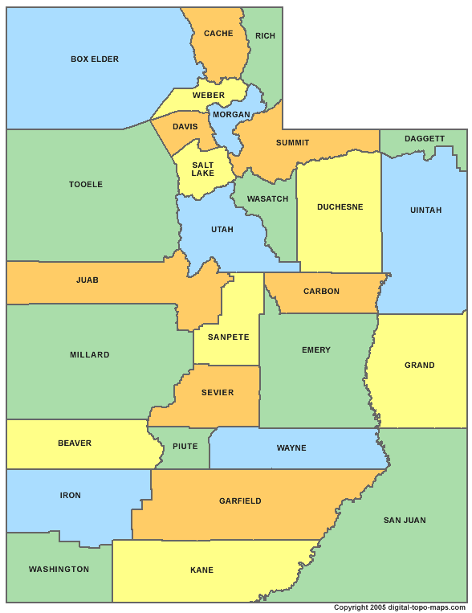
Washington
(Kane)

Iron
(Emery)

Beaver
(Daggett)

Millard
(Weber)

Juab
(Wasatch)

Tooele
(Duchesne)

Box Elder
(Beaver)

Cache
(Morgan)

Rich
(Carbon)

Weber
(Iron)

Morgan
(Juab)

Davis
(San Juan)

Salt Lake
(Wayne)

Summit
(Sevier)

Wasatch
(Box Elder)

Utah
(Tooele)

Duchesne
(Millard)

Carbon
(Summit)

Sanpete
(Grand)

Emery
(Uintah)

Sevier
(Washington)

Wayne
(Cache)

Piute
(Sanpete)

Garfield
(Rich)

Kane
(Davis)

San Juan
(Salt Lake)

Grand
(Utah)

Uintah
(Garfield)

Daggett
(Piute)

WELCOME TO . . .
NOW TRAVEL TO . . .

