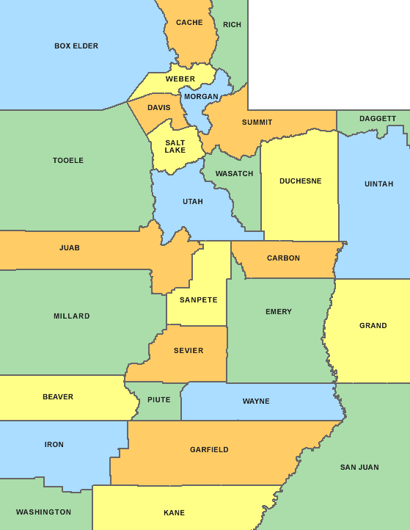

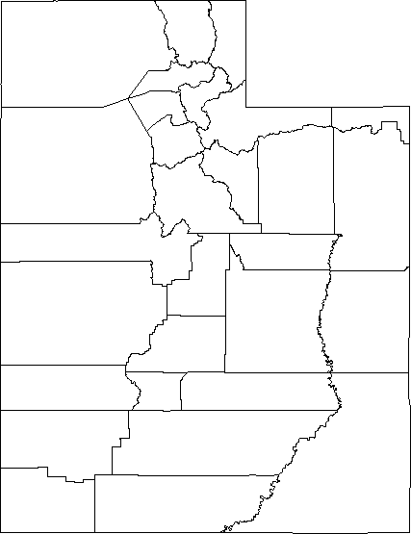

COLORFUL MAP: https://www.waterproofpaper.com/printable-maps/county-map/printable- utah-county-map.gif

BLANK MAP: https://www.waterproofpaper.com/printable-maps/utah/printable-utah-county- map.pdf

