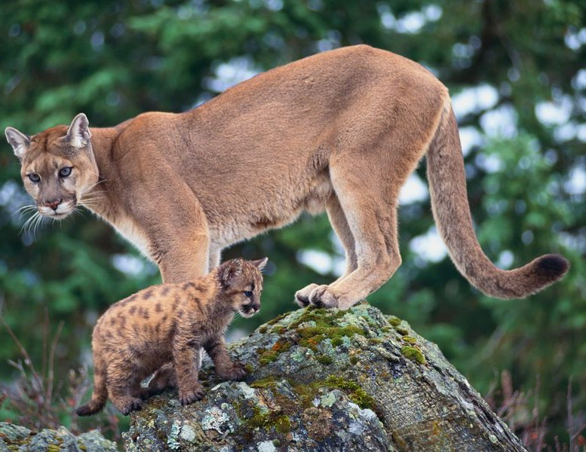

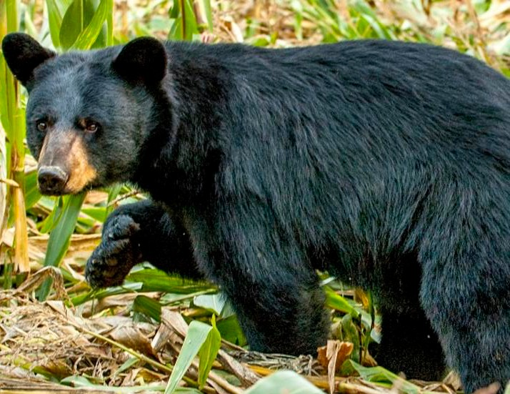

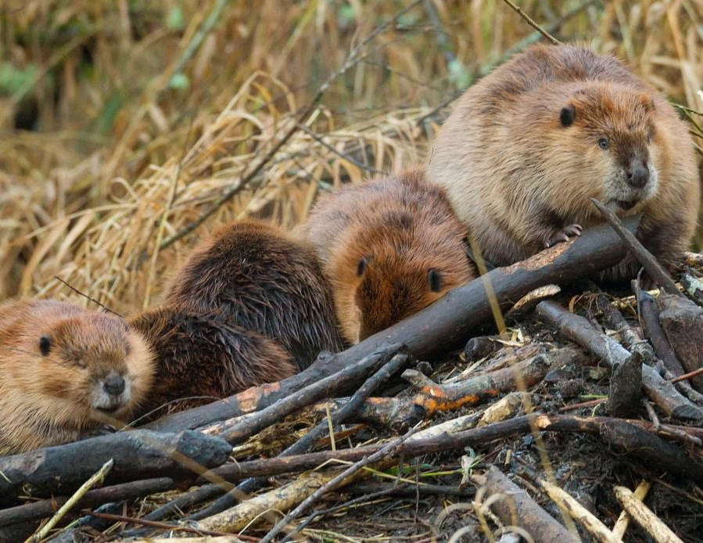

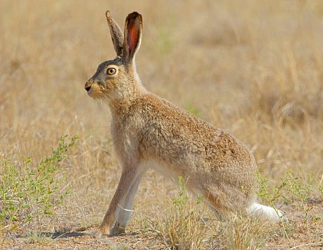

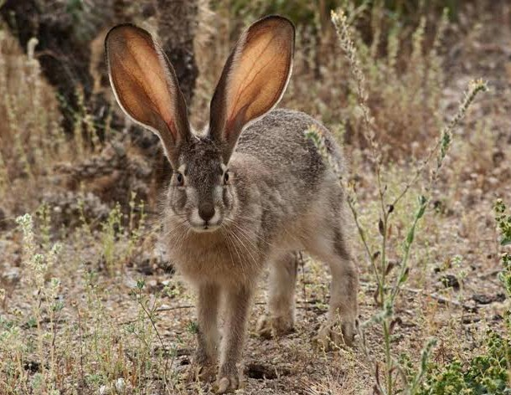

The BLACK TAILED JACKRABBITS
- Do not change fur color from summer to winter
- Live in open prairies, foothills, and sparsely vegetated deserts
- Go out in the early evenings and early mornings
- Eat green vegetation of shrubs, small trees, grasses & forbs
- Have long, broad ears to release heat to stay cool

WHITE TAILED JACKRABBITS
- Change fur colors in summer and winter for camouflage
- Hide in a depression on a hill to watch for predators
- Live in grass or sagebrush
- Eat mainly grasses, bark, and small twigs
- Are nocturnal animals
- Have long, broad ears to release heat to stay cool

MOUNTAIN LIONS
- Live in all habitats in Utah
- Prefer rough and rocky cliffs, ledges, rugged hills from deserts, foothills, and mountain areas where trees, brushes and bushes are found for cover
- Have sharp, retractable claws
- Have long, pointed teeth
- Are very silent and powerful when they hunt
- Have keen vision
- Are an accurate judge on the movement of their prey
- Are very patient while hunting
- Will bury their kill to eat for the next two weeks
- Have a light brown color that camouflages it within the rocks

BLACK BEARS
- Live in dense wooded areas
- Have a thick layer of fat grown in the fall for winter
- Hibernate for 6 months of the year
- Have claws that are curved sharply
- Are very agile & have short, powerful legs for running 30 mph
- Climb trees and swims well
- Are omnivores
- Eat meat left from another animal’s kill

BEAVERS
- Have webbed hind-feet for swimming and propulsion
- Have large flat tails for a rudder and for balance
- Have transparent membranes over their eyes to see underwater
- Have ears and noses that have valves that close underwater
- Have sharp teeth for cutting wood and they keep growing throughout their lives
- Have two coats of fur for protection
- Hold their breath under water for 15 minutes

