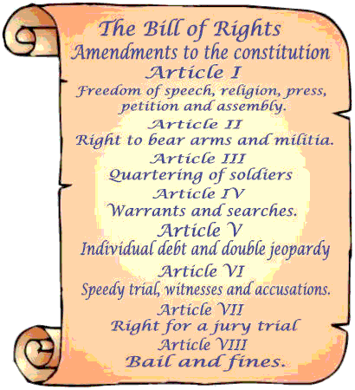
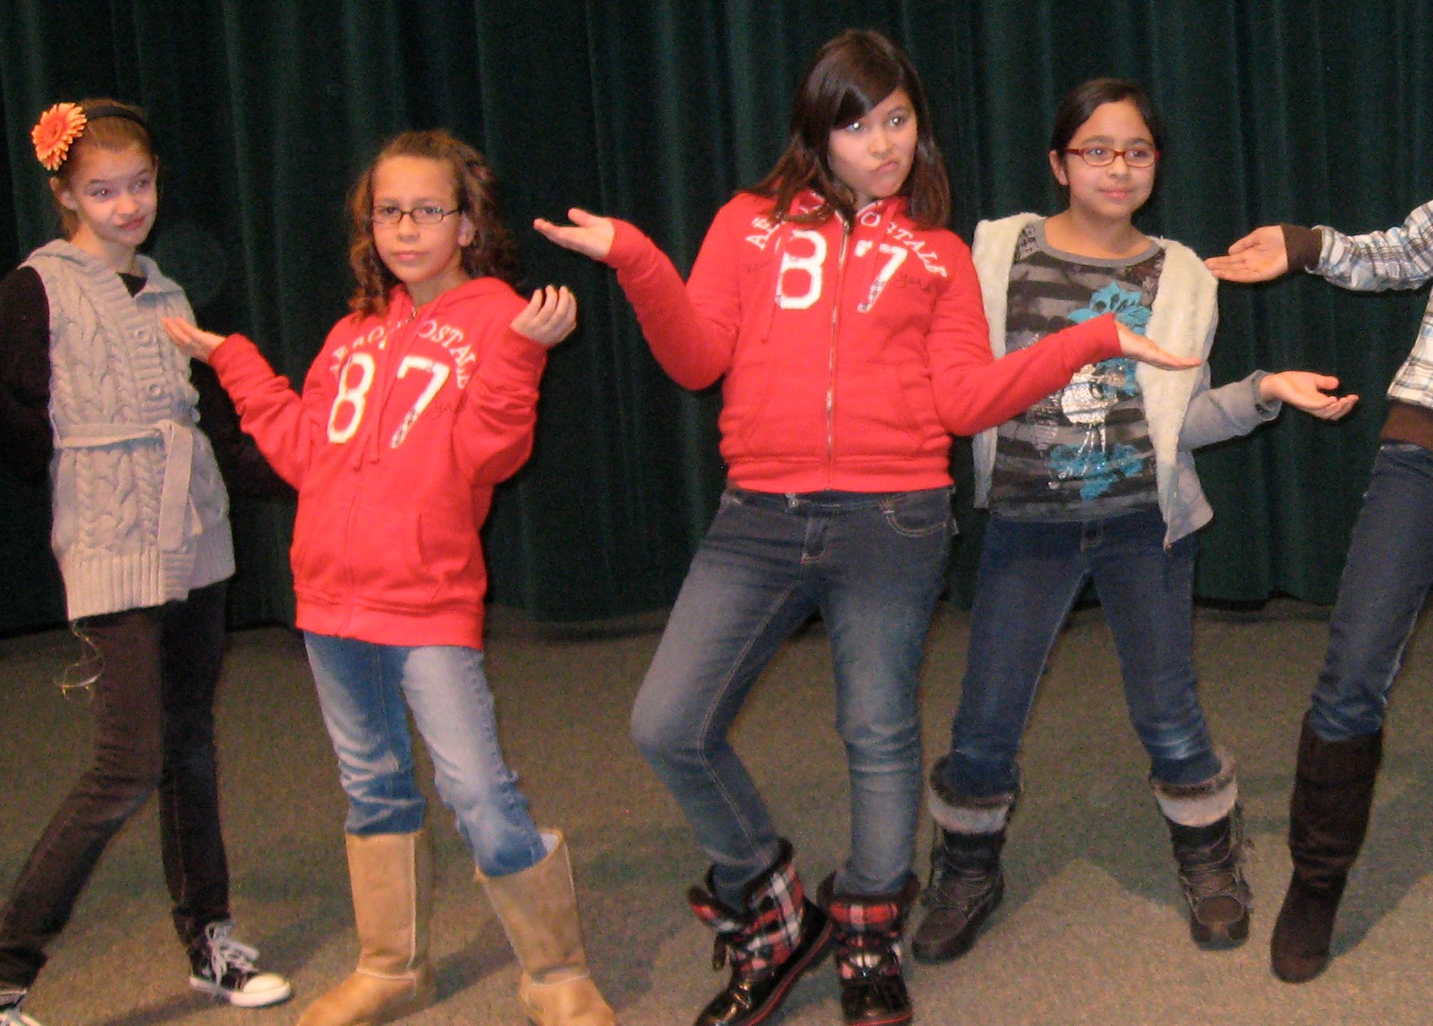
Rap the Bill of Rights
5th Grade Social Studies/Dance

Core Curriculum,
Social Studies, Standard 3
Students will understand the rights and responsibilities guaranteed in the United States Bill of Rights.

Dance, Standard 5.D.CR.2:
Use a variety of stimuli and solve multiple movement problems to develop choreographic content.

Objective: In a 45 minute class 5th grade students will demonstrate their understanding of the 10 amendments on the Bill of Rights by creating and performing a Rap Dance based on movement, exploration of gestures, shapes, and axial movement.

Materials:
Music: Bill of Rights, artist: Flocabulary, album: Hip-­‐Hop U.S. History, genre: Hip Hop/Rap. (I got permission to use it)
I edited the song to repeat each amendment 3 times. I also made a CD that each track is one amendment and repeats many times (This way the students can practice with many repetitions)

Dance elements chart.
Power Point Presentation with a simplified version of the Bill of Rights, and the Flocabulary version.

Copies of the slides of the PowerPoint to distribute to each group in the class.

Introduction:
Bill of Rights: who wrote them? Why is this document important to us today?
Rap: etymologically means, "fast read" or "spoke fast". Rapping can be delivered over a beat or without accompaniment. It tells a story.
What is a gesture? Tell me the different shapes on the dance elements table, name axial movements, part of the body.

Moving:
Teach a simple hip-­‐hop step. I did step touch, shoulders are a little hunched over, add sharp arms to your step.

Exploring and Investigating:
Briefly explain the amendment. As a class come up with gestures, shapes, and axial movements to portray each key word of each amendment. Help them identify the key words. I recommend doing two amendments all together as a class. For example, amendment 3, I ask: should we do a shape or axial movement for soldier, they choose shape. Then I ask: weak or strong, straight or bent. Always referring to the dance elements table.

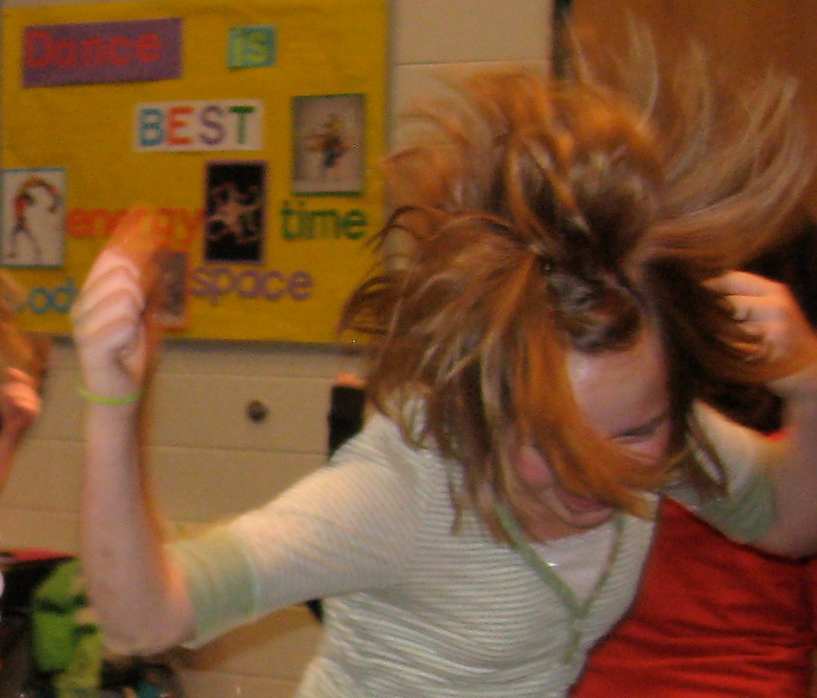
Example:
Amendment Three: When soldiers get sleepy, you don't have to let them sleep up on your couch.

Soldier: strong straight shape Sleepy: weak curved shape, melt Couch: wide shape.

Amendment Six: You must process me speedily. Process: punch one hand to the other, like a judge Speedily: quick run in place

Creating:
Have the students get into 8 groups. Give each group one amendment and have them come up with gestures, shapes, and axial movements for each key word.
Also, have them come up with their own “hip-­‐hop step.” They love this!

Have the class get in a big circle. Have each group teach their amendment to the whole class. Have them practice with the whole song. At the end of the song, it says: “this is the bill of rights” many times, each group dances their own “hip-­‐hop step,” improvise, and hold their last shape.

Practice and Performing:
Divide the class in half and have them perform for each other. I let the audience clap and cheer in the middle of their dancing, so they motivate the dancers.

Connect and analyze:
Have them think about and share which amendment is the most important for them right now and why (which amendment applies to them personally.)

Number One
The Bill of Rights LYRICS
by Flocabulary

Freedom of religion, speech, and press,
plus you can assemble in crowds and protest.
Number Two
Right to bear arms and cannons,
I bet the Minutemen didn't know about handguns.
Number Three
When soldiers gets sleepy,
you don't have to let them sleep up on your couch.
Number Four
No one can search and seize.
It protects me, unless people have a warrant to arrest me.
Number Five
If you arrest me, respect me.
Sorry Alex, there's no Double Jeopardy.
What’d you do after school? "I plead the fifth." (What’d you do after that, dude? "I plead the fifth." I don't have to incriminate myself or risk my health,
whenver I'm in trouble, I just plead the fifth.) I took this part out.
Number Six
You must process me speedily.
Number Seven
In front of my peers on the jury.
Number Eight
You can't use cruel or unusual punishment.
(You can't make me drink turpentine for the fun of it.) I took this part out.
Number Nine
The people get more than these rights.
Number Ten
States can make other laws, and they just might. This is the Bill of Rights.

Bill of Rights (1791)
After the leaders of the new United States wrote the Constitution, they had to get the thirteen states to agree to it. Some of the states didn't want to agree unless they could add some specific rights for individual people. So in 1791 the United States added ten new rights to the Constitution. These are called the Bill of Rights.
These are the ten rights that are in the Bill of Rights:

- Congress can't make any law about your religion, or stop you from practicing your religion, or keep you from saying whatever you want, or publishing whatever you want (like in a newspaper or a book). And Congress can't stop you from meeting peacefully for a demonstration to ask the government to change something.

- Congress can't stop people from having and carrying weapons, because we need to be able to defend ourselves.

- You don't have to let soldiers live in your house, except if there is a war, and even then only if Congress has passed a law about it.

- Nobody can search your body, or your house, or your papers and things, unless they can prove to a judge that they have a good reason to think you have committed a crime.

- You can't be tried for any serious crime without a Grand Jury meeting first to decide whether there's enough evidence for a trial. And if the jury decides you are innocent, the government can't try again with another jury. You don't have to say anything at your trial. You can't be killed, or put in jail, or fined, unless you were convicted of a crime by a jury. And the government can't take your house or your farm or anything that is yours, unless the government pays for it.

- If you're arrested, you have a right to have your trial pretty soon, and the government can't keep you in jail without trying you. The trial has to be public, so everyone knows what is happening. The case has to be decided by a jury of ordinary people from your area. You have the right to know what you are accused of, to see and hear the people who are witnesses against you, to have the government help you get witnesses on your side, and you have the right to a lawyer to help you.

- You also have the right to a jury when it is a civil case (a law case between two people rather than between you and the government).

- The government can't make you pay more than is reasonable in bail or in fines, and the government can't order you to have cruel or unusual punishments (like torture) even if you are convicted of a crime.

- Just because these rights are listed in the Constitution doesn't mean that you don't have other rights too.

- Anything that the Constitution doesn't say that Congress can do should be left up to the states, or to the people

