Kindergarten & 1st Grade Creative Dance Lesson Plan
I Love to Rhyme!

Written by Jana Shumway
UTAH CORE STANDARDS
KINDERGARTEN READING: Foundational Skills Standard 2: Demonstrate understanding of spoken words, syllables, and sounds (phonemes). a. Recognize and produce rhyming words. DANCE Strand: CREATE (K.D.CR.) Standard K.D.CR.4: Respond to suggestions and change movement through guided improvisational experiences. DANCE Strand: CONNECT (K.D.CO.) Standard K.D.CO.2: Describe and demonstrate movements organized around a specific topic.
LENGTH OF LESSON 60 minutes (Two 30 minute sessions)

MUSIC AND MATERIALS
Youtube Video “Words Shine When They Rhyme” Words to put on the wall or whiteboard:
Base Words: Ball, Cat, Tree, Dog, Red, Day Rhyming Words:
Ball: Crawl, Small, Doll, Wall, Fall, Tall Cat: Scat, Bat, Fat, Splat, Hat, Flat Tree: Bee, See, Me, Ski, Flee, Three Dog: Log, Smog, Frog, Clog, Fog, Jog
Red: Bed, Head, Fled, Shed, Dead, Sled Day: Hay, Lay, Stay, Clay, Play, Sway
Music: Any of the following songs would work for background music while you dance the poems:
“Intro” by The XX; “Monkeybiz” by D1ofaquavibe; “Mali-Cuba” by AfroCubism; “Drive Away (End Title)” by Thomas Newman; “Transcendence” by Lindsey Sterling; “The Magic Carpet” by Brent Lewis

SESSION ONE SET UP
Put the six base words up on the wall or whiteboard: Ball, Cat, Tree, Dog, Red, Day. They will be headings of columns so line them up side by side, not up to down. Then to the side of all of those base words put the small rhyming words in a scattered formation.

INTRODUCTION
Show the YouTube Video “Words Shine When They Rhyme”. Tell the kids we get to rhyme words today.

Show the kids the base words on the wall. Read each word slowly. Ask if the words rhyme. “Does ball rhyme with cat? Does tree rhyme with day? Does red rhyme with ball? No, they don’t! So let’s find some words that rhyme with those words.” Out of the rhyming words scattered on the wall or whiteboard, pick one of the scattered words and try to find the base word with which it rhymes. “Does crawl rhyme with cat? No. Does crawl rhyme with red? No. Does crawl rhyme with ball? Yes! We found a rhyme!” Put the word “crawl” under the base word “ball”.

Then ask the kids to look at all the scattered words to see if they can find more words that rhyme with “ball”. Call on kids who have found a word, then test it to see if it rhymes. If it rhymes put the word under the base word “ball”. Keep adding rhyming words under “ball” until all six rhyming words are there.

CREATE / PERFORM DANCE THE POEMS
Now have the kids stand up and spread out to dance the BALL POEM. Say it slow enough, and with a pause at the end of each phrase, so there is time to do the movement.
An example might be:

BALL POEM

I bounce like a ball Bounce in a curved shape And now I can crawl Crawl on the ground
I’m shrinking so small Stand up quickly so you can then slowly shrink to a small shape Now I dance like a doll Dance staccato like a wind up doll
I skip to the wall Skip to a wall
Oops I will fall Fall in a creative way to the floor Yet now I grow tall Grow into a tall, high leveled shape
And that is all! Switch the shape quickly to a new high leveled shape

NOTE: The order of the poem does not matter, and the verbs you throw into the poem do not matter. Just make up a poem on the spot using the order that resulted from the kids finding the rhyming words. Remember to throw in some good action verbs to help make it easier to dance.

Continue to find the rhyming words for each of the base words. As soon as you have the six rhyming words under one base word, then dance that poem. Do this for each of the base words until you have danced all six poems. Here are examples of each poem. Yet again, your poems will be in a different order depending on which rhyming words the kids find first, second, third, and so on.

BALL POEM
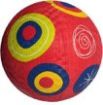
I bounce like a ball And now I can crawl I’m shrinking so small I dance like a doll
I skip to the wall Oops I will fall
Yet now I grow tall And that is all!

CAT POEM
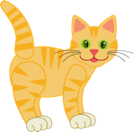
I arch like a cat And now I will scat Feet up like a bat I’m growing so fat Watch me now splat
And shake off my hat Then lay down real flat And that is that!
TREE POEM
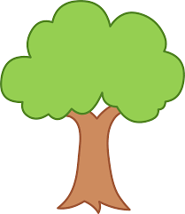
Sway like a tree Now fly like a bee
Make waves in the sea Hey look . . . it’s me! Zig Zag I ski
Turn into a 3 Now I must flee
Wheeeee!! Wheeee!!

DOG POEM
Beg like a dog Now roll like a log
Push hard through the smog And jump like a frog
Watch out there’s a clog Now creep like the fog It’s time to jog
Yes jog, jog, jog!

RED POEM
An apple is red
Now sleep in your bed Pop up your head Run fast like you fled Now hide in your shed Have fun playing dead
Slide down on your sled Your red slippery sled!
DAY POEM
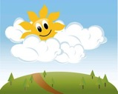
I’m loose like the hay And now I will lay
Don’t move watch me stay I mold into clay
Up and go, let’s play And now start to sway All the long day
Hey! . . . Hey! Hey!

SESSION TWO
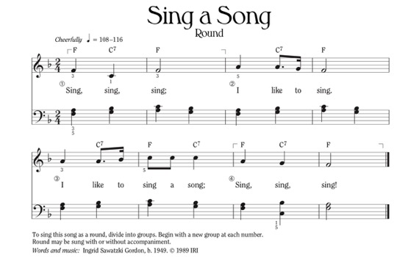
Review dancing a couple of the poems from above. Remind the children about how the last word in each
poem rhymes.

RESPOND / CONNECT
Teach the children the following song (sung to the tune of “Sing A Song - Round” by Ingrid Sawatzki Gordon):

Rhyme, Rhyme, Rhyme I like to rhyme
I like to rhyme my words. Rhyme Rhyme Rhyme.
Sing it a few times.

Then put the smaller rhyming words scattered all over the floor.

Have the children sing the song while they skip around the words on the floor. When the song ends they must stop by the closest word. (Another option would be to just
play music while they skip around, then
when you stop the music they can to go to the nearest word). They will read the word then make a shape or do movement of a word that RHYMES with the word. For example, if they stop by the word HEAD they could make the shape of a BED, or pretend to be DEAD, or make the shape of a SLED, etc. This is easier for 1st graders, yet some will still struggle with this. However, this activity will let you know who understands how to rhyme as you walk around to see their rhyming words. If needed, you can do this in pairs for kindergartners so they can help each other.

After you’ve done this activity several times, have each child pick up two words off the floor and put them under the correct base word on the wall. This, too, lets you know which child understands how to rhyme.

You can also practice this activity on other days. Hopefully their rhyming skills will improve!

