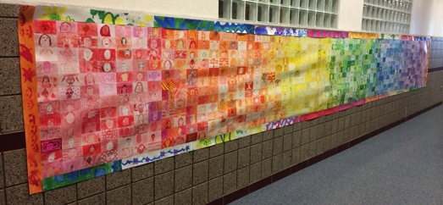

Core Curriculum, K-2 Content
3a: Express personal experiences and imagination through…visual art

3rd Social Studies
1a: Identify the elements of culture (artistic expression)
1b: Describe how…artistic creations serve as expressions of culture

4th Social Studies
S3O1d: How the influence and power of individuals is affected when they organize into groups
Leader in Me
Synergize
Begin with the End in Mind
Color Wheel Self-Portrait Mural
All Grades
Social Studies / Leader in Me / Visual Arts Written by: Rachel Weber, 6th Grade
Adapted from: elementaryartfun.blogspot.com

Visual Arts Curriculum,
K.V.CR.2 Build skills in various media and approaches to art-making; use art materials, tools, and equipment in a safe way;
1.V.CR.1 Engage collaboratively in exploration and imaginative play with art materials, and use observation and investigation in preparation for making a work of art.
2.V.CR.3 Demonstrate safe procedures for using and cleaning art tools, equipment and studio spaces.
3.V.CR.4 Individually or collaboratively construct representations, diagrams, or maps of places that are part of everyday life.
4.V.CR.2 Collaboratively set goals and create an artwork that is meaningful and shows the intent of the makers.
5.V.CR.2 Experiment with and develop skills in multiple art-making techniques and approaches through practice.
6.V.CR.3 Demonstrate openness in trying new ideas, materials, methods, and approaches in making works of art and design.

Objective: Students will learn about the color wheel, how to draw a simple or detailed face (depending on the grade), and then will create a piece of a mural using one or two colors.

Materials:
- Blank 3x5 index cards (one for each student in the school—and a few extras)
- Colored pencils or crayons (split up by color family)
- Online videos or knowledge of how to draw a face
- Google Spreadsheet
- List of how many students are in each class at the school
- Butcher paper
- Glue sticks

Much of this lesson may seem self-explanatory, and maybe you can come up with a much better and more efficient way of coming to the same outcome/product. I will basically describe my own tips and tricks, organization, and the things I learned while helping my school create this fun piece of art that the whole student body can enjoy and feel a part of.

  - Using a current list of the number of students in each class, create a Google Sheet that has the colors across top, teachers’ names on the left side, and the totals across the rows and down the columns. If you know how to create a sheet with an equation function to add it for you, it will save you a ton of time. This sheet should have two pages, one will have the main colors of the rainbow, and the one for 5th-6th that has sets of two colors that are next to each other in the rainbow. (5th-6th grades will be creating the in-between sections that blend the colors together.) This will help you stay somewhat organized, and if you give permission to the teachers you share with, they will be able to adjust their class if they have move-ins, or absent students. Make sure you tell them to pay attention to the numbers at the bottom so you can try to keep the groups as even as possible across the board. (see example below)
Class | Red | Orange | Yellow | Green | Blue | Purple | Total
Smith | 5 | 5 | 5 | 4 | 5 | 4 | 28
Jones | 4 | 4 | 5 | 5 | 5 | 4 | 27
Total | 9 | 9 | 10 | 9 | 10 | 8

  - In a faculty meeting and in a corresponding email, explain in detail what you need the teachers to do for this project. I have copied the email I sent onto the following webpage: http://worldwidewebervideos.weebly.com/mural-email.html
You may use much of what I have on there, but please change the links that are specific to my school so you don’t confuse your faculty. Since 95% of what needs to be done for this project can be found there, I will not repeat it on this lesson plan.
  - I found some instructional videos for those who feel “artistically challenged” and not able to teach how to accurately draw a face. Those videos, and some of the information can be found on this site:
http://worldwidewebervideos.weebly.com/color-wheel-self-portraits.html Feel free to share this with your faculty.
  - 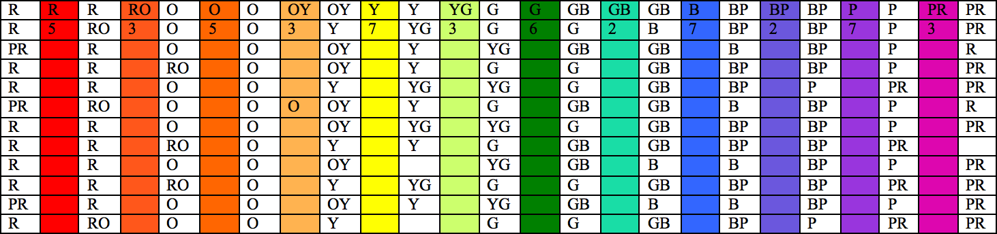When it came down to putting the whole thing together, it took some time, math, and figuring stuff out to know exactly how many rows and columns would fit all of the portraits. Each column has 12 portraits. I had my class help me split up the portraits by color so I could count them to make sure I had the correct number. I then created a spreadsheet to organize the amount of columns and extra cards so I could use it as a guide as I glued the whole thing together. (see below) In each column, the number near the top represents the number of columns that had to be only that color. I took the extras and tried to mix them in the rows in between the main rows. This helped me know how many should be mixed in the blended rows. We were three portraits short of a full mural (notice the blank boxes). I just took three extra cards and made patterns on them in the colors for the section I needed them in.
  - I also organized the ones with two colors into three groups. Example: more red, half and half, more orange. This helped the blending areas be more gradual.
  - I glued these onto butcher paper in 4-5 foot increments. This is very difficult to laminate if it is much longer than that. The paper is 36” wide, so the cards fit perfectly if they are just touching each other. I glued these while on the floor. I would suggest using kneepads if you do this, because my knees were sore for about a week afterward. If you have a large counter space in your school that you can access from both sides, I would suggest using that instead. I found it easier to have someone applying glue to the portraits while another person affixed them to the paper.
  - I wanted to hang this where all of the students would have a chance to look at it closely, so I decided it would be better to laminate it, since I knew it would be touched. (Also, when you move it, some of the portraits that are not glued as well tend to try to peel off) I went to the Instructional Support Center to laminate the sections of the mural. They have a large

laminator that they turn on upon request. If you call ahead, they will turn it on so you can use it when you arrive.
  - Affix it to the wall with either packing tape or staples, depending on the type of wall you have. I would suggest affixing it one section at a time. I did not do this, and it tends to sag a bit on some sections.
  - For the border, I had students paint designs and patterns on butcher paper, then cut 3” strips and laminated them. The original one on the blog was done by the kindergarteners instead of them doing a portrait, but our kindergarten teachers wanted them to do a portrait like everyone else.

Problems I encountered:
- One class decided to do their portraits vertical, which threw off the measurements, so they had to do theirs again horizontally.
- A few classes didn't emphasize the need for the entire picture being done in ONE color. If they used two, and they happened to be colors that were next to each other in the color wheel, we were okay. If they used more than two, or if they were not next to each other in the color wheel, then they had to be sent back to be redone.
- Pink and red/violet: where do they go? I had many use red/violet instead of red, and pink kind of throws things off. I would suggest either pulling these out, or only allowing them to be used in the red/purple section for the upper grades.
- Pencil, or no pencil? Decide, and stick with it. It can be hard to see the details on the yellow pictures, but if you have the students use more of a golden yellow that is darker or a light tan, it can be done.
- Color the backgrounds! I had my students lightly fill in the ones who only drew a face, but did not color or add a background.
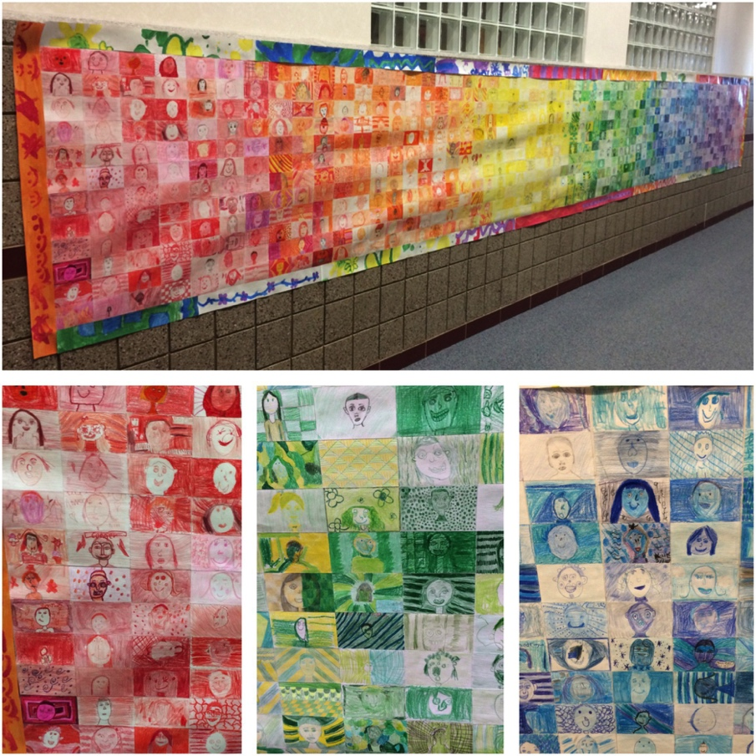
- Kindergarten wanted to participate, but did not think their kids could draw their own ovals. I traced ovals on each of the kindergarten cards in the appropriate colors. You can decide if it is necessary. I think it would have added more character if they did it themselves. Either way is fine.
- Differences in color: I did not care which medium was used as long as it was not oil pastel. If you have a set of supplies that can be passed around the school, it will be much more consistent. Having a little inconsistency just added to the personality of the whole project. Just make sure you address colors that can throw off where it should go: red/violet, yellow/green, etc.

